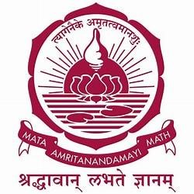

AMRITA VISHWA VIDYAPEETHAM, BANGLORE



An Internship Completion Report in

“ZF Wind Power Coimbatore Private. Ltd”

Submitted in partial fulfilment for the Award of degree of Bachelor of Technology In

Mechanical Engineering

**Submitted to Submitted By**

Department of Loheth S & Ashwin S Bapat

Mechanical Engineering, Batch 2019 – 2023 ASE Bengaluru.

Department of Mechanical Engineering

Amrita Vishwa Vidyapeetham, Bengaluru

July. 2022



ACKNOWLEDGEMENT



We are very thankful to **ZF Group** for giving us the opportunity to undertake our summer Internship at their **ZF Wind Power Coimbatore Private. Ltd**. It was a very good leaming experience for us to have worked at this site.

We would like to convey our heartiest thanks to Mr. Nachimuthu K, Deputy Manager, for guiding us and encouraging us during our internship period. we would also like to give my heart-felt thanks to Mr. Parthiban Pranesh, HR recruiter, who heartily welcomed us for the internship.

Last but not the least, we would like to thank all the staff of **ZF** family, for being so helpful during this Internship.

ABOUT THE COMPANY



In India, ZF is one of the leading providers of technology solutions and services that creates trend across the country. The group has been operating on the continent for more than 60 years. India is very important as the ZF growth market and the Group has strong plans for the country. Most ZF Group structures and business units already exist in India and cater for the automotive and nonautomotive parts of the country.

ZF operates in India with three subsidiary companies, four joint ventures, and eight international engineering centres. ZF India Pvt regional headquarters. Ltd., is a productive area in Chakan, Pune. India's ZF has a strong presence nationwide and has grown steadily into 18 production centres across the country. The ZF Aftermarket division provides a wide range of backup product components to popular brands like SACHS, LEMFÖRDER, TRW, and WABCO with strong service support.

ZF Wind Power is a world-renowned designer, manufacturer and supplier of advanced gearbox solutions, providing major manufacturers of wind turbine powered gears with an output gearbox of up to 9.5MW and providing all critical wind power components.

ZF products are integrated into coastal and coastal wind farms. ZF Wind Power has a worldwide history of production in Belgium, Germany, India, China and the US.

ZF Wind Power Coimbatore (India) has a state-of-the-art manufacturing facility, a fully integrated gearbox production facility that provides India and the needs of a 5,500 MW global turbine power plant. ZF Wind Power Coimbatore is committed to being the leading supplier to the Indian market, dedicated to making wind energy the most attractive energy source.





WEEKLY OVERVIEW

OF INTERNSHIP ACTIVITIES



|  |  |  |
| --- | --- | --- |
| **Week 1** | 13-06-2022 | Basic Intro + Safety instructions |
| 14-06-2022 | Wheels soft 2.1 |
| 15-06-2022 | Shaft soft 2.2 |
| 16-06-2022 | Shaft hard 2.3 |
| 17-06-2022 | Wheels hard 2.4 |
| 18-06-2022 | Incoming Quality |

|  |  |  |
| --- | --- | --- |
| **Week 2** | 20-06-2022 | Incoming Quality |
| 21-06-2022 | Ring Wheel |
| 22-06-2022 | HT Carburising |
| 23-06-2022 | HT Nitriding |
| 24-06-2022 | Housing |
| 25-06-2022 | PLC & TA |

|  |  |  |
| --- | --- | --- |
| **Week 3** | 27-06-2022 | Quality &CMM Gears |
| 28-06-2022 | Quality &CMM Castings |
| 29-06-2022 | Incoming Quality |
| 30-06-2022 | Incoming Quality |
| 01-07-2022 | Washing and Kitting (ATP) |
| 02-07-2022 | Pre-Assembly |

|  |  |  |
| --- | --- | --- |
| **Week 4** | 04-07-2022 | Main-Assembly |
| 05-07-2022 | Testing |
| 06-07-2022 | Painting |
| 07-07-2022 | SCM &SQA |
| 08-07-2022 | Final Review |

Table of Contents

INTRODUCTION 7

WHEELS SOFT 9

SHAFT SOFT 10

SHAFT HARD 12

WHEELS HARD 14

INCOMING QUALITY 15

RING WHEEL 16

HEAT TREATMENT 18

HOUSING 19

PLC & TORQUE ARM 21

QUALITY AND CMM - GEARS 22

QUALITY AND CMM - CASTINGS 23

PRE-ASSEMBLY 24

MAIN-ASSEMBLY 25

TESTING & PAINTING 26

SCM&SQA 27

CONCLUSION 28

# INTRODUCTION

Gears are described as wheels with teeth that transmit energy and movement through them at a constant speed from one shaft to another.

Gear drives offer the following advantages when compared with chains or driving belts:

* It is a compact drive and the speed limit remains constant.
* The distance between the shafts is very small, which leads to integrated construction.
* It can transmit more power compared to belt or chain drive.
* It can transmit movement at very low speeds, which is not possible with a belt drive.
* The efficiency of gear drive is comparably extremely high.

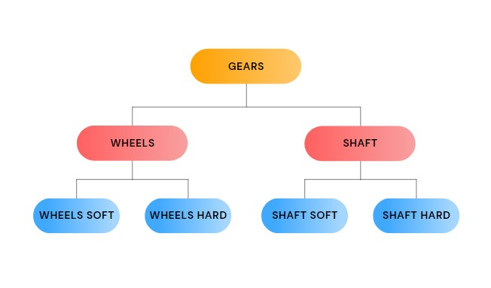

Some of the common Machining process,

* **Turning:** Turning is a machining operation in which the work piece rotates at high speeds while a fixed cutting tool removes material.

* **Milling:** Milling is the process of machining using rotary cutters to remove material by advancing a cutter into a work piece.

* **Facing:** Facing is the process of removing material from the end of a work piece, using a special tool to produce a smooth surface perpendicular to the rotational axis of the work piece.

* **Deburring:** Deburring is a material modification process that removes sharp and unfinished edges from a material, and leaves the material with smooth edges.

* **Chamfering:** Chamfering is done by making a small cut at an angle of 45 degrees in order to remove a 90-degree edge.

* **Hobbing:** Hobbing is a process of using rotatory machining tools to make teeth on different type of gears as required.

# WHEELS SOFT

Wheels soft comprises of all the machining process that is carried out before the heat treatment process.

The processes include Turning, Hobbing, Chamfering and Deburring.

**Process 1 –** Turning is done on one side of the wheel.

**Process 2 –** The wheel is tilted and turning is done on the opposite side.

**Process 3 –** Hobbing and gear profile milling process is carried out.

**Process 4 –** Deburring and tooth chamfering.

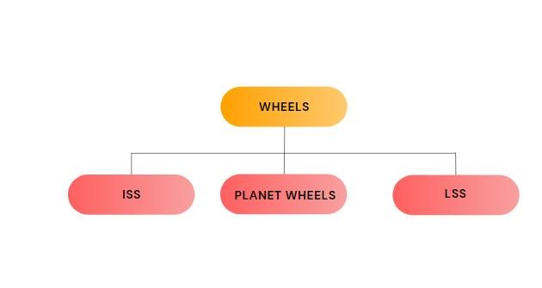

* Hobbing is carried out for 3-7 hours and it mainly depends on the size of the component.
* The hobber has about 12 rows, which is used to cut the profile of the teeth, after the hobbing process is done, it’s sharpened and put back into use.
* The hobber is sharpened using grinding operation with the help of an abrasive tool.
* A tilting operation is carried out to turn the other side of the wheel.
* The hobbing process results in the formation of burs and these burs are later removed using Deburring machine, the leftover burrs are manually removed later and the wheel is then sent to the warehouse and is followed by heat treatment.

# SHAFT SOFT

Wheels soft comprises of all the machining process that is carried out in the shaft before heat treatment process.

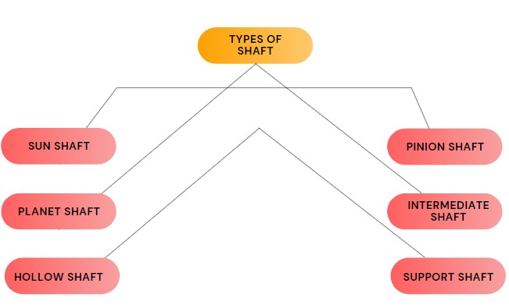

Machines used in shaft soft:

* Horizontal machining.
* Grinding machines.

Different types of machining operations are carried out depending in the type of shat that is used. The operations are listed down in the table below.

|  |  |  |  |  |
| --- | --- | --- | --- | --- |
| **Sun shaft** | **Pinion shaft**  **&**  **intermediate shaft** | **Planet shaft** | **Hollow shaft** | **Support shaft** |
| * Drilling * Turning * Facing * ID bore * Tapping * Gear   Hobbing  (Helical)   * Gear   Hobbing  (Spline)   * Deburring   (Helical  & Spline) | * Facing * Cantering * Drilling * Tapping * Gear hobbing * Tooth deburring * Keyway milling | * Facing * Cantering * Drilling * Tapping * Turning horizontal | * Horizontal turning * Keyway milling * Internal spline * Deburring | * Turning horizontal * Drilling * Deburring |

* After all the machining process the components are sent for heat treatment.
* For Planet shafts Induction hardening is done instead of heat treatment.
* Induction hardening is a heat treatment process that is performed to improve mechanical properties in the local area of a steel section.
* Induction hardening is done in planet shaft because only the outer surface of the planet shaft comes in contact during the working phase.
* Oil packets are also added to planet shaft to provide lubrication to the bearing, which helps in reducing the frictional loss.

# SHAFT HARD

* Shaft hard is the process that is carried out after the heat treatment process.

**Different machines used:**

* Straightening press-

The pinion shaft usually tends to bend after the heat treatment process and the deformation happened is corrected using a straightening press.

* Re-centring machine-

This machine is mainly used to recentre the hole after heat treatment process.

* Grinding machines-

These machines are used for grinding operations, abrasive cutting tools of different shapes are used.

Types of grinding:

* 1. Centre grinding
  2. Profile grinding
  3. OD grinding
  4. ID grinding
  5. Tooth profile grinding

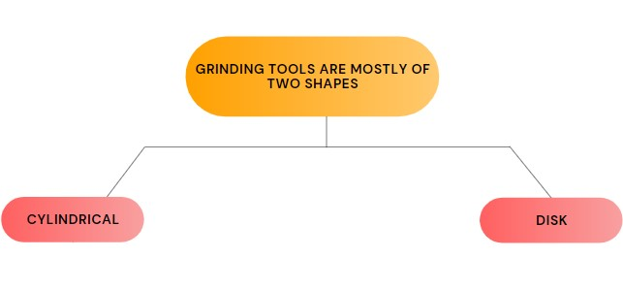

* Turning Machine-

Turning process is carried out on a planet shaft after induction hardening takes place.

# WHEELS HARD

* Wheels hard is a process that is carried out after the heat treatment process in wheels.

**Different machines used:**

* Grinding machine
* Turning machine
* Cutting machine
* Key-way machine

Different types of machining operations are carried out depending on the requirement.

* First, hard turning is done on the fast wheel and slow wheel and then surface finish is carried out.
* The wheel is checked for stock and is flipped used a tilting set-up and is sent for profile grinding.
* For planet wheels, the same process is called as cone grinding. Prior to this process, a roughing is done for removal of 1mm stock in order to avoid any damage on the grinding wheel.
* 2 – 2.5 hours of machining is required for cone grinding and 1 -2 hours for keyway machining depending on the part and dimensions.
* Later, the wheel is loaded on a cutting machine and clamped. The cutter follows an up and down motion to create a keyway hole.
* This machine cuts about 10-20 microns per stroke.

# INCOMING QUALITY

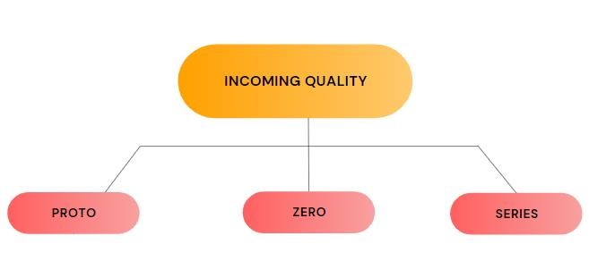

* Proto (First piece):

One prototype is sent by the supplier is examined and the required changes are informed is needed.

* Zero:

Five prototypes of the same model are examined and if it’s casting, only one prototype is examined. This is mainly because casting has more than 300 elements present in it, which is extremely time consuming.

* Series:

This comes into play only after the component got approved in proto and zero. A series of components will be produced and supplied.

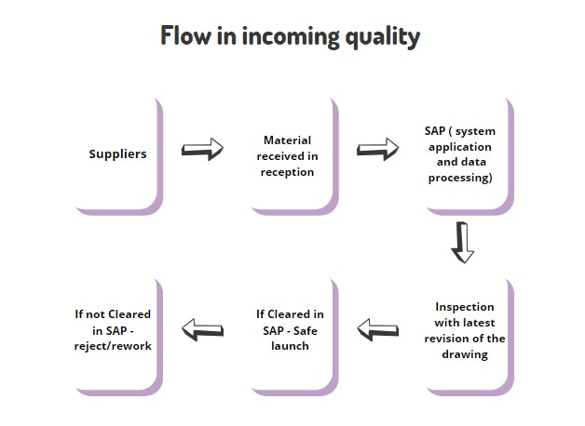

# RING WHEEL

The main function of a ring wheel is to support the planet carrier, to convert low torque into high speed in a wind turbine.

Order of the process:

* Rough turning and milling

* Internal gear hobbing

* Deburring

Removal of burrs from the material to provide a smooth surface finish.

* Finish turning and milling

* Internal gear profile grinding

* Heat treatment (Nitriding)

Nitriding process is done only in ring wheels and planet wheels, because they tend to deform under carburising process.

* Glass blasting

Using glass particles as a medium to provide uniform finish on the component by shooting the glass beads towards the particle at a high pressure.

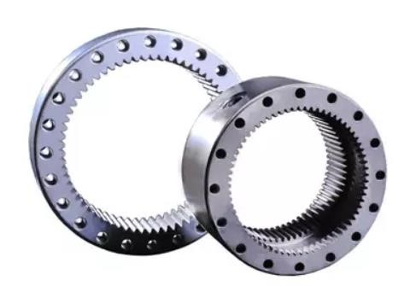

# 

# HEAT TREATMENT

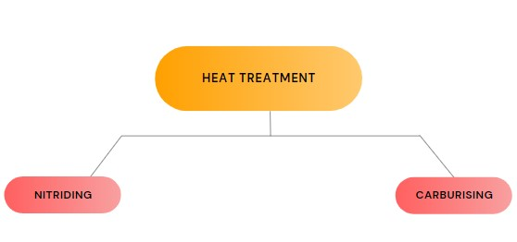

* Heat treatment refers to a controlled process of heating and cooling an object in order to improve its properties and performance.
* Nitriding and Carburising is basically the process of diffusing a gas into the component when heated.

|  |  |
| --- | --- |
| **Nitriding** | **Carburising** |
| * Hollow shaft and Ring wheel * Quenching operation is not required * Heated around 500 degrees Celsius * Components are placed inside the furnace for 5 days | * Lss, Iss, Planet shaft, sun shaft, pinion shaft * Quenching is required * Heated above 900 degrees Celsius * Components are placed inside the furnace for 3 days. |

* Nitriding is an expensive process compared to Carburising.
* Shot blasting is a process of shooting metals balls at the surface of the component at high pressure to clean the external surface. (Carburising).
* Using glass particles as a medium to provide uniform finish on the component by shooting the glass beads towards the particle at a high pressure is called glass blasting. (Nitriding).
* Major gases used in Nitriding – Nitrogen and Ammonia
* Major gases used in Carburising – Nitrogen, propene and carrier gas.

# HOUSING

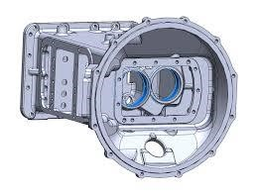

* Gear drive is most commonly used because of its high output efficiency and contact velocity ration.
* Two types of horizontal machining centers are used
  + - 60 tools in one section with 4 sections.
    - 120 tools in the total section.

* Double pallet machine is used to reduce the time loss and improve the efficiency of the machine.
* Types of operations carried out: ✓ Milling
  + Drilling
  + Bore
  + Deburring
  + Tapping
  + Finish milling

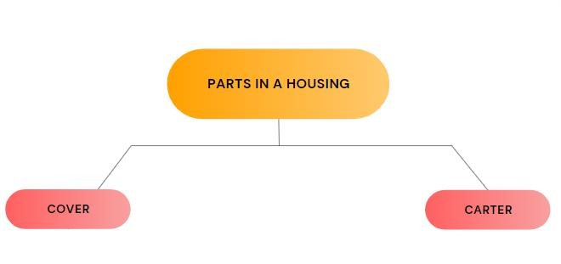

* The manufacturing time taken for the cover - 3hours, carter -

4 hours, finish assembly process - 10 hours

# PLC & TORQUE ARM

* The planet carrier helps in containing all the other shafts like sun shaft, plant shaft and ring gear to create a successful energy transmission.

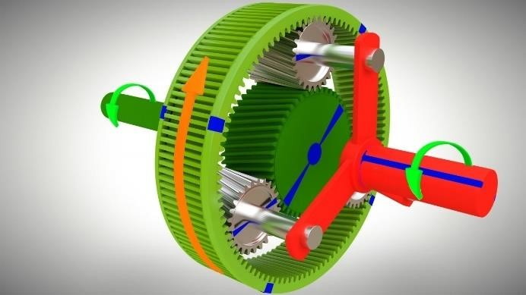

* Double pallet machines are used to reduce the production time of the component in face milling and grooving process.
* Operations involved:
  + Milling
  + Drilling
  + Boring
  + Internal job profile grinding
  + Deburring
  + Tapping
  + Finish milling

* Torque arm is an extra arm support which is attached to the ring wheel during the assembly process to absorb torque reactions.
* The machining operations used are vertical milling, rough turning, drilling, tapping, face milling, finish turning.

# QUALITY AND CMM - GEARS

* CMM – Coordinate measuring machine
* A CMM machine is mainly used to check different parameters of a finished component before it is put into use.
* Parameters checked:
  + Lead

Lead torsion is divided into top, middle and bottom.

* + Profile

Profile torsion is divided into tip, middle, root.

* + Gera spacing/Pitch
  + Pitch circle
  + Tip circle
  + Runout
  + Cone
  + Circularity
  + Cylindricity
* A Truing dial is used to place the gear in the machine centre.

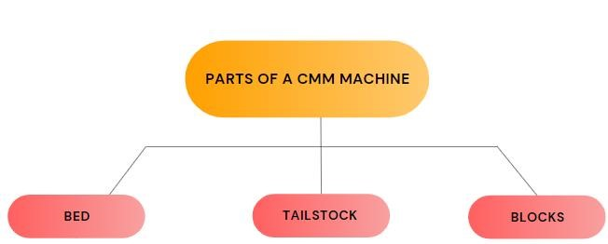

# QUALITY AND CMM - CASTINGS

* Dimensional inspection is done in CMM casting
* Parts/components inspected under CMM casting:

* + Ring wheel - Gear geometry
  + PLC – GD&T
  + Housing – GD&T
  + Torque arm – GD&T
* Different types of styluses are used depending on the need of inspection.
* Two ball point tips are used to reduce wear failure.

RED - ruby

WHITE - ceramic

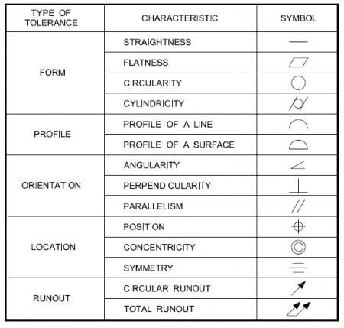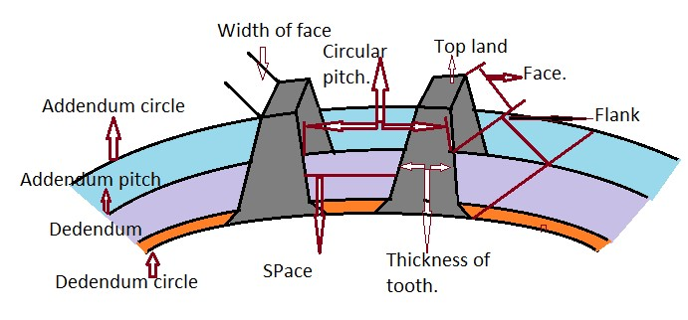

# PRE-ASSEMBLY

* There are two types of planet carriers:
  + PC1
  + PC2
* Planet carrier 2 is always smaller compared to PC1.
* The bore of the planet carrier is expanded by heating the PC at 180 degrees Celsius in an oven for 8 hours.

Oven temperature-180 degrees Celsius

Component temperature-160 degrees Celsius

* Later, air cooling is done using forced air.
* There are two types of bearings:

TRB bearing

Plain bearing

* A component called labyrinth is used to do provide and circulate lubricant in the planet shaft.
* Hylum wheel is used to do the torque checking to relieve stress and improve the fit.
* There are two types of torque:

✓ Break free torque ✓ Continuous torque

Torque checking process:

* The shaft has three holes in the top, bottom and middle.
* Pressurized oil is used to break the fit.
* The gun used to rotate the planet wheel is called as atlas copco tool.

# MAIN-ASSEMBLY

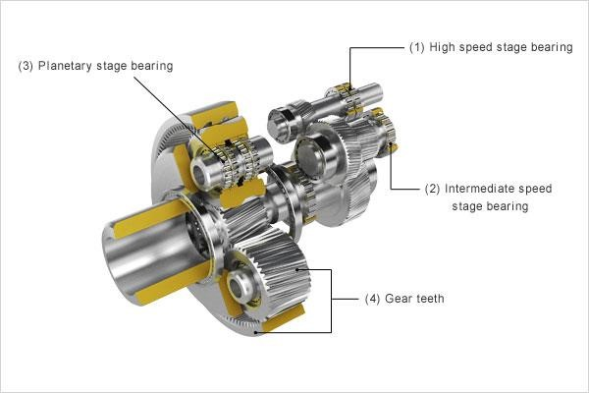

* There are 2 major types of gearboxes manufactured:
  + 1P2H (1 PLC, 1 Housing, 2 Hollow Shafts)
  + 2P1H (2PLC, 1 Housing, 1 Hollow Shaft)
* 1P2H has 3 steps of assembly and the order of work goes by step 1,3,2.
* Step 1 is the housing assembly (split into 3 parts A, B, C) on the rotor side to fit in LSS, HSS, and ISS, and step 3 is the hub assembly on the generator side to fit 1 PLC, and step 2 is the assembling of the whole gearbox using a Manipulator.
* 2P1H has a similar assembly process, where there are 3 stages of assembly and the order of work goes by Stage 1,3,2.
* Stage 1 is the housing assembly on the rotor side to fit in HSS and HS-IS, and stage 3 is the hub assembly on the generator to fit 2 PLC's, and stage 2 is the whole gearbox assembly using a Manipulator with sun shaft running through the whole assembly.

# TESTING & PAINTING

* Once assembled, the gearboxes are tested with a full load to check for vibration and noise behaviour mainly and also, the temperature of bearings, oil pressure, etc
* This is done by placing a second gearbox back-to-back with first to put the load on
* To ensure that the surface of the gearbox has no contact with other surfaces, the torque arm is clamped to the sides of the testing rig
* Sensors and mic around the testing rig help us analyse the running of the gearboxes Painting
* If tests are successful, the gearboxes are sent to the painting booth and painted according to customer’s specifications
* After the whole assembly, testing and painting process, sensors, electrical systems, or oil pump are placed if required

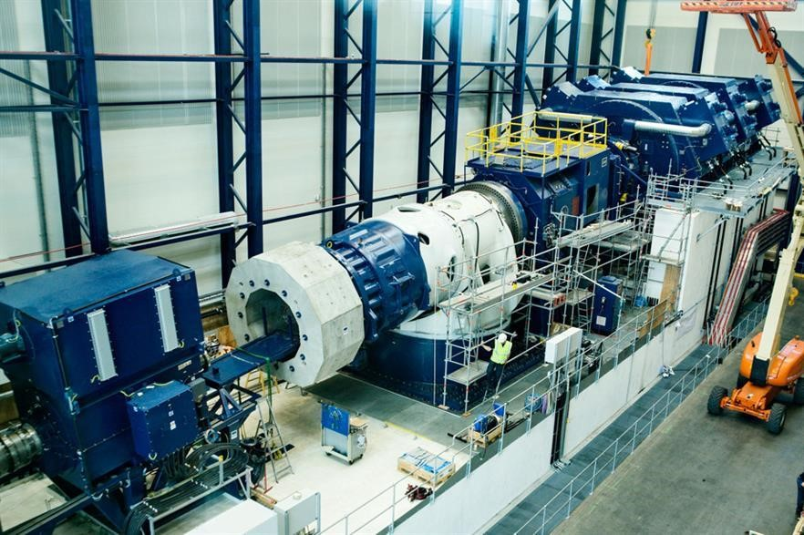

# SCM&SQA

* At the most important level, supply chain management (SCM) manages the flow of goods, data, and costs associated with a product or service, from procurement of goods to delivery of a product to its final destination.

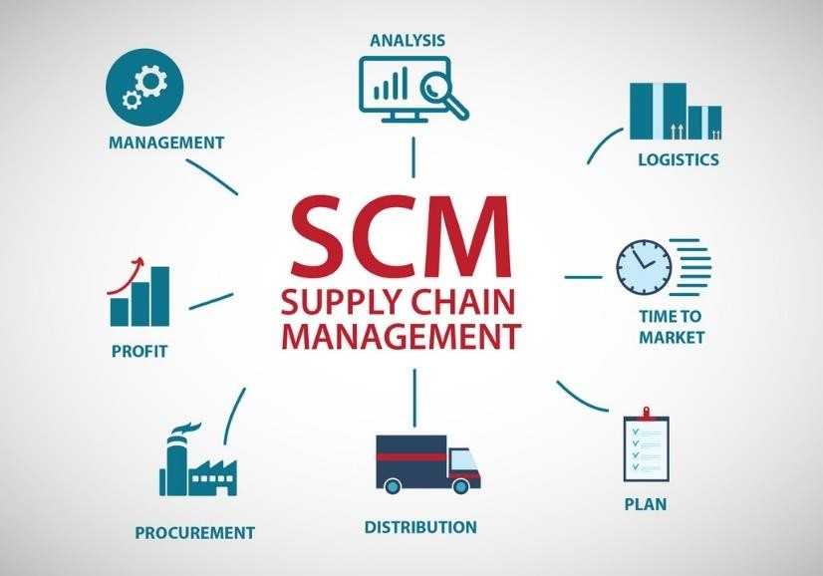

* Software quality assurance (SQA) is a process that ensures that advanced software meets and complies with the specified or standard quality specifications. SQA is an ongoing process within the life cycle of software development (SDLC) that constantly evaluates advanced software to ensure it meets the required quality standards.



# CONCLUSION

It was a wonderful learning experience at **ZF Wind Power Coimbatore Private. Ltd** for one month in Coimbatore. I gained a lot of insight regarding almost every aspect of the industry. I was given exposure in almost all the departments at the plant. The friendly welcome from all the employees is appreciating, sharing their experience and giving their peace of wisdom which, they have gained in long journey of work. I hope this experience will surely help me in my future and also in shaping my career.